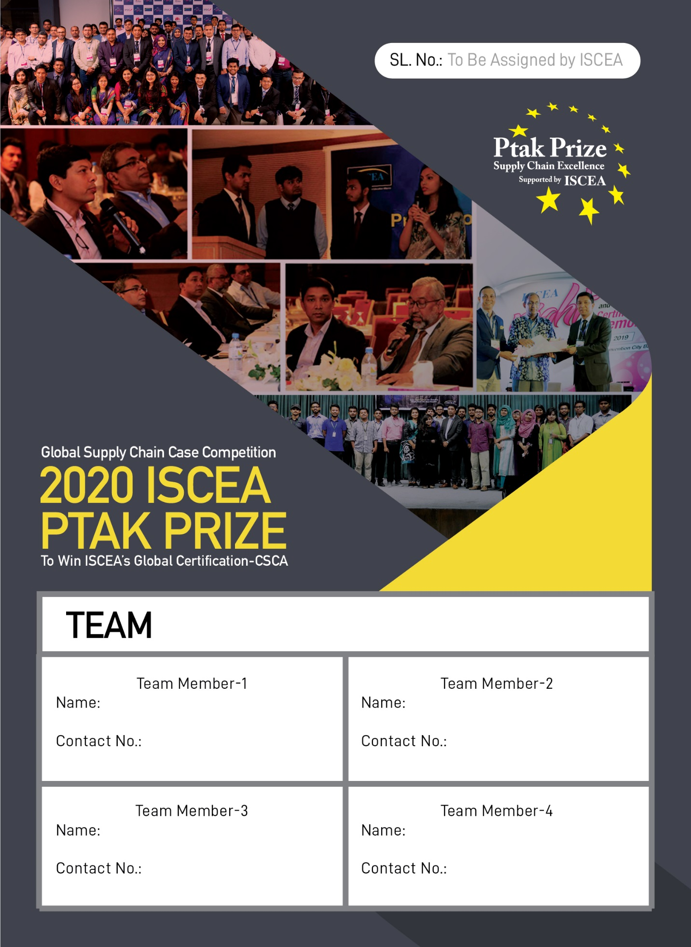

**MXUB-0168-20**

01684701870

01627414346

MD. Riadhul Islam Rumu

Drishti Saha

Aseer Anwar

01521450560

Md. Rakat Hassan

01678355707

**Table of Content**

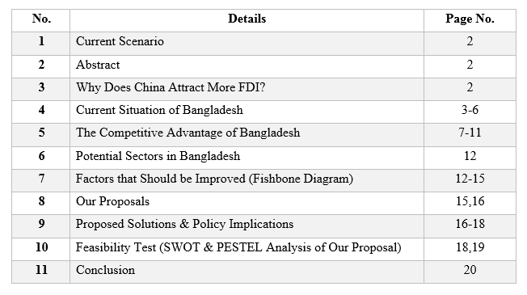

**Current Scenario**

Day by day coronavirus pandemic creates an enormous economic disaster worldwide. As a result, investors are thinking critically to determine the pros and cons of their businesses before investing in a foreign country. So, it is high time to grab the opportunity for ‘Bangladesh’ to attract investors to move out of them.

**Abstract**

Due to the unexpected situation, ‘China's’ global manufacturing sector is in a great crisis. Therefore, Bangladesh can create applicable supply chain proficiency to attract foreign investors by feasible policymaking. So, the government of ‘Bangladesh’ (GOB) mainly focused on governing areas to concretize their plan. For this, some potential manufacturing sectors are manifest such as RMG, Leather, Electronics, Automobiles, etc.

**Why does China attract more FDI?**

If we consider the reason behind that, we can find several explanations. Some of the major causes are:

* Free trade zone (Across the country)
* Excellent transportation system
* Economical advantage
* Immense local market
* Proper legal support
* Worthy government policies
* Political stability
* Standard infrastructure
* Availability of raw materials
* Low cost for trade
* Skilled human resource
* Technological gain

**Current situation of Bangladesh**

Recently the inflow of foreign direct investment in ‘Bangladesh’ is low because of the coronavirus outbreak. According to (Nordea 2020), FDI inflows to ‘Bangladesh’ fell by 56% in 2019 compared to 2018. This indicates that the situation is not favorable in the current time. But the scenario will be changed in the upcoming future, as we have seen this country has a very good growth level of FDI in its history rather than the current time.

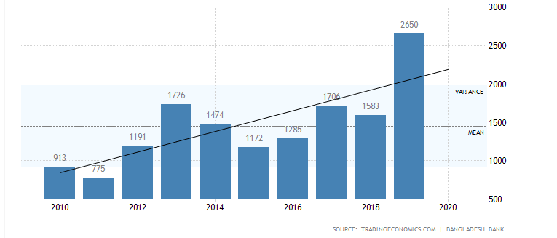

If we consider the previous records, then ‘Bangladesh’ has a very good score by which any companies can feel interested to invest here with credibility.

FDI inflow depends mostly on the country’s transportation, power, and communication. If we look closely at the infrastructure of ‘Bangladesh’ then we find that between the years, the physical structure has improved. But many problems still exist.

Then transportation sectors are assisted financially by the ‘World Bank’ by which the government is taking a comprehensive transport plan. A glimpse of ‘Bangladesh’s’ current transportation system:

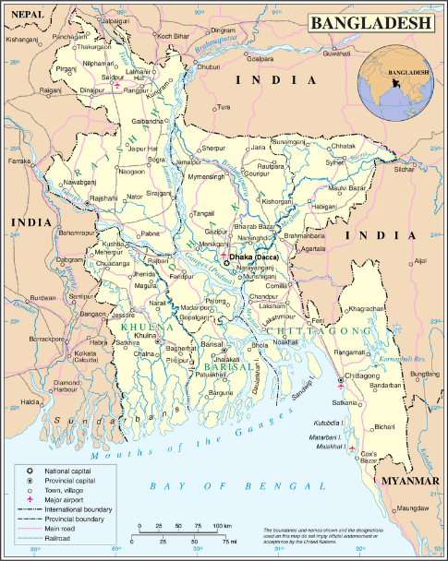

On the other hand, the role of government on energy plan are well arranged for both current and future time. Their electricity plan till 2021 of ‘Bangladesh’ is given below through grid map:

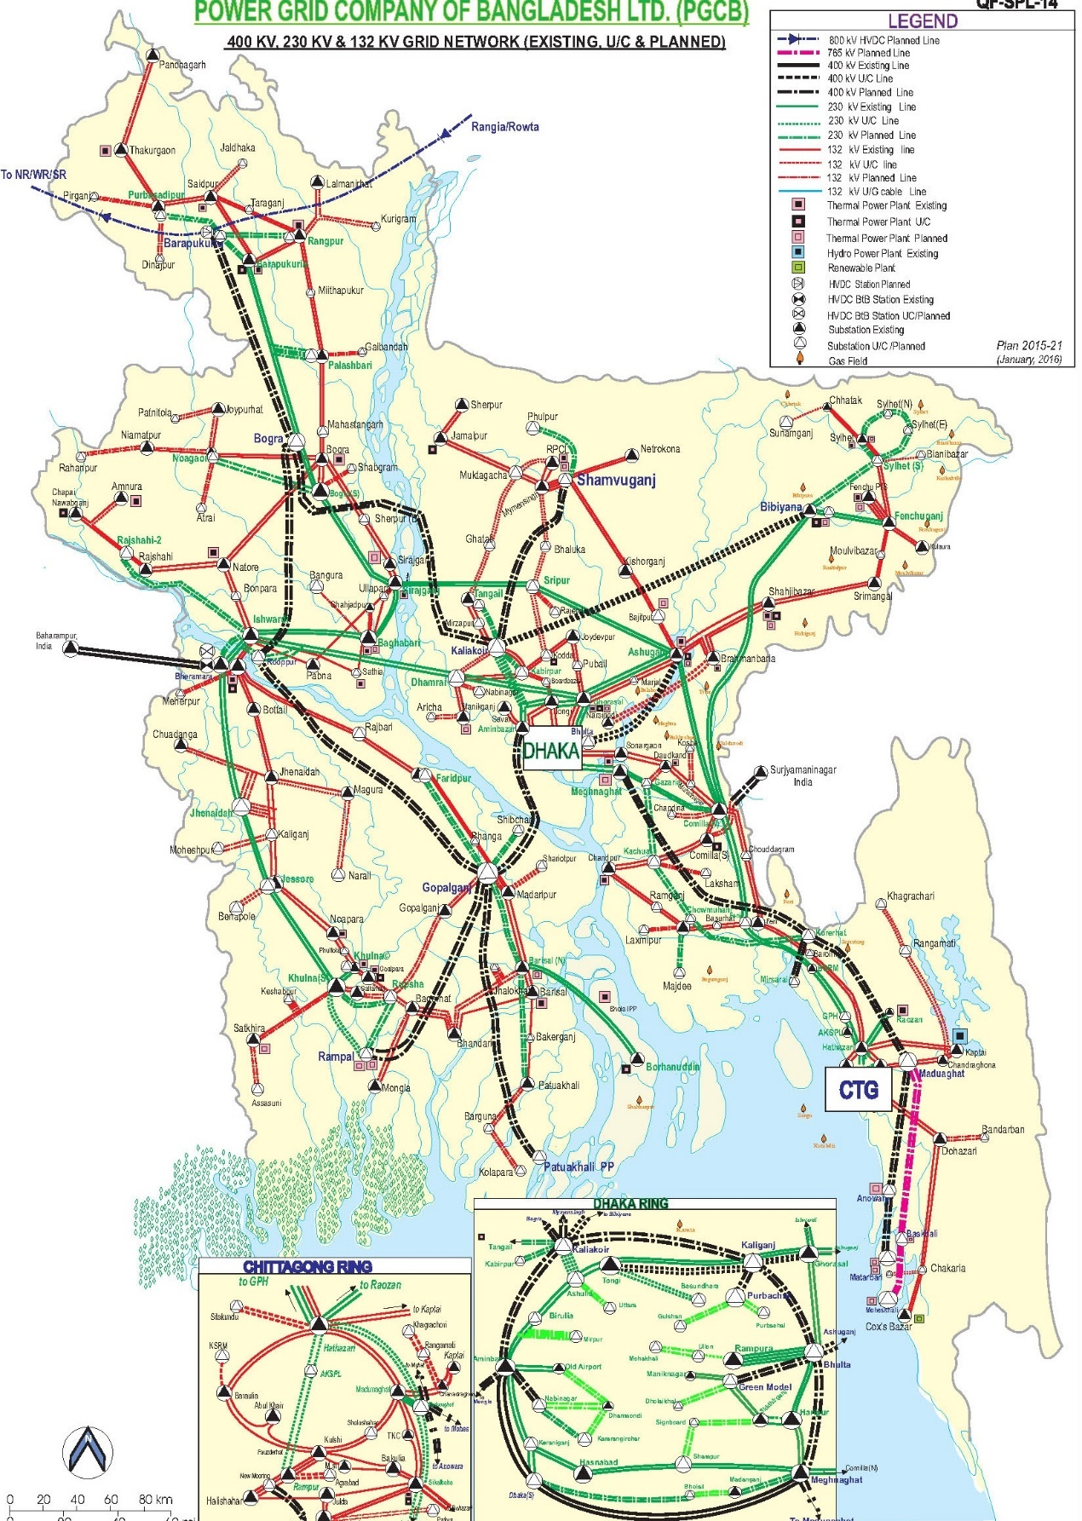

The current energy plan of the government consists of gas, coal, oil, etc. energy sources in the target period of till 2030. According to their scheme, the energy mix for power generation is:

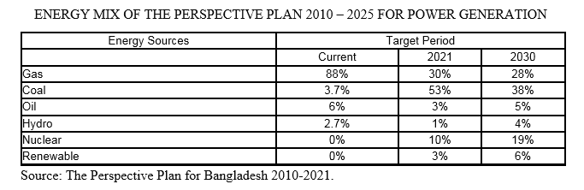

Currently, the government takes some effective initiatives to make this country digitalized as much as possible. By adapting ICT policy and principles the government aims for successful digital ‘Bangladesh’ in 2021 through communication and technology. Till now the growth is:

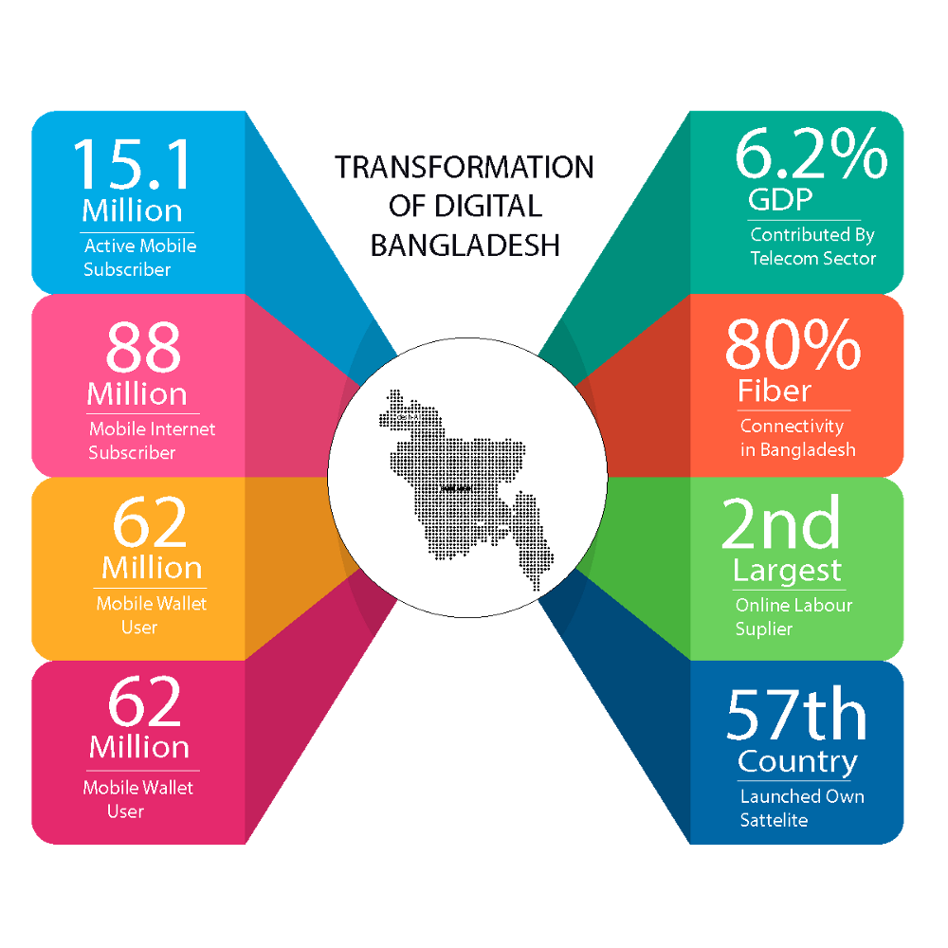

**The competitive advantage of Bangladesh**

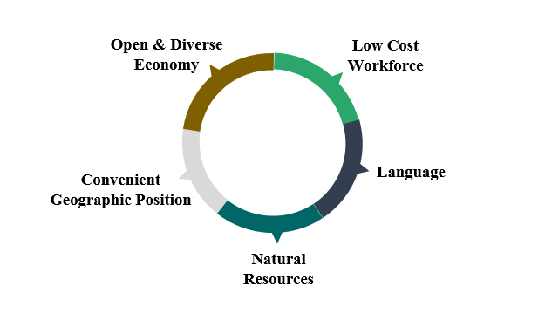

Firstly, there is no fully open or closed economic country in the world. But in terms of trade restrictions, ‘Bangladesh’ is much more opened as the country broadened their trade by easy policy-making for the foreign investors. The competitive advantage is, the country reducing its cost of doing business and openness to global trade day by day. In the end, statistically, the country’s economy will be 23th largest in 15 years.

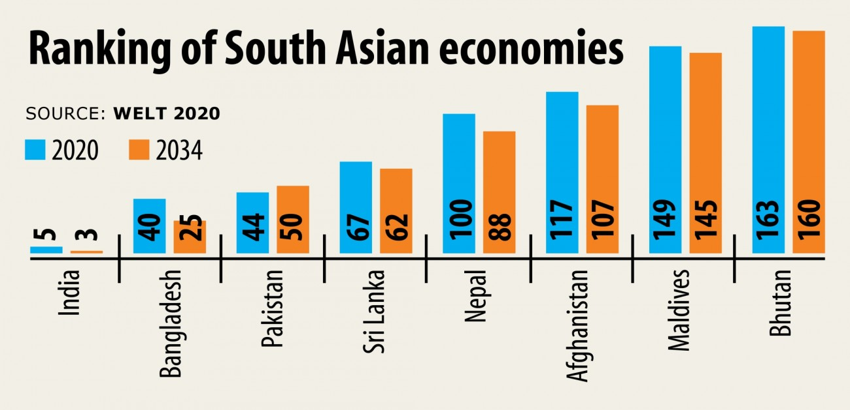

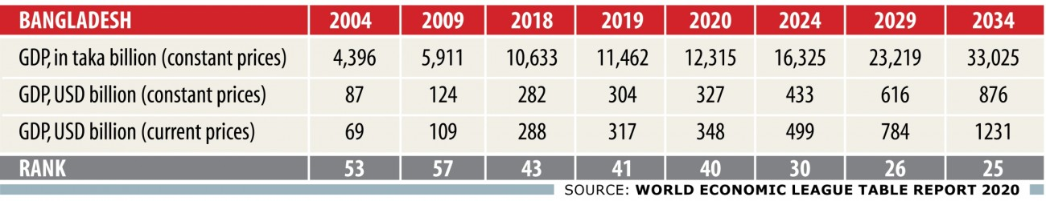

Secondly, the countries one of the major viable advantages is the low labor cost. Export-oriented industries can generate their revenue easily as they can produce more by using the additional advantage of the cost-cutting system. According to (countryeconomy.com n.d.), the comparison ‘Bangladesh’ vs ‘China’ in terms of wages from 2002 to the current year.

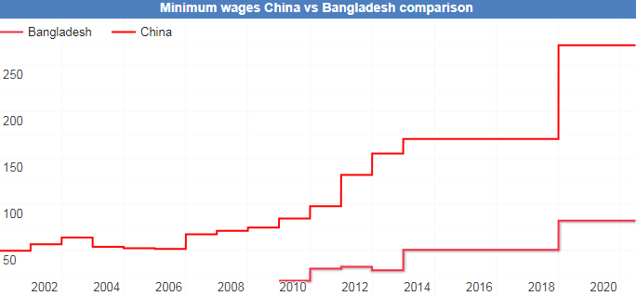

Thirdly, the geographical position of this country is in a great way where ‘Bangladesh’ finds itself in the Asia-Pacific reign. This location gives the country competitive advantages both for import and export goods straightforwardly. So, different ports are framed for the smooth circulation of trading among the countries which gives ‘Bangladesh’ extra benefit for doing business.

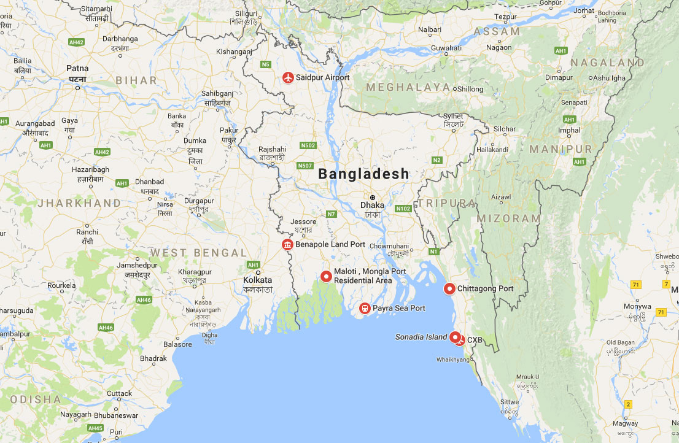

Fourthly, the second language of ‘Bangladesh’ in English. This international language is important as it helps to make easy communication between the country's buyers/sellers with foreign buyers/sellers. According to (Wikipedia n.d.), the country has a higher percentage of English speaking populations than ‘China’ and ‘India’.

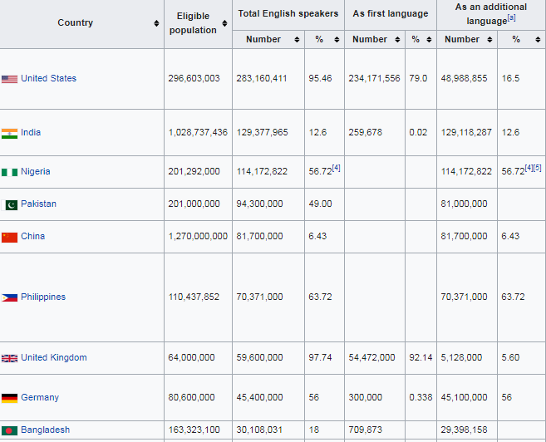

Finally, some of the natural resources of ‘Bangladesh’ create competitive advantages. Natural gas is the highest natural resource in this country. Coal, limestone, hard rock is also here enormously. A huge quantity of these makes them available at a low cost which creates the path of efficient manufacturing. According to (Suntrace 2019), ‘Bangladesh’ energy situation is given below:

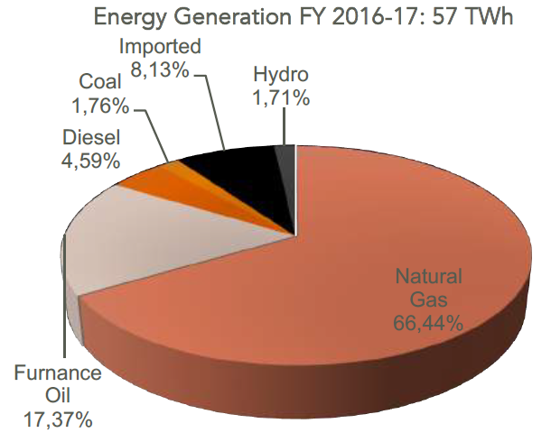

**Potential Sectors in Bangladesh**

Some of the top export-oriented potential sectors in ‘Bangladesh’ are:

* RMG & Apparel Industry
* Leather & Leather Products
* Agricultural Products
* Jute and Jute Products
* Frozen Fish Products
* Pharmaceuticals

All of these sectors export goods and earn revenue almost double from 2018 to 2019. For attracting foreign investors in ‘Bangladesh’, we choose the RMG, apparel, and leather industry among the potential sectors. According to our investigation, we also saw many possibilities in electronic and automobiles sectors. In the end, our proposal will consist of these four sectors.

**Factors that should be improved (Fishbone Diagram)**

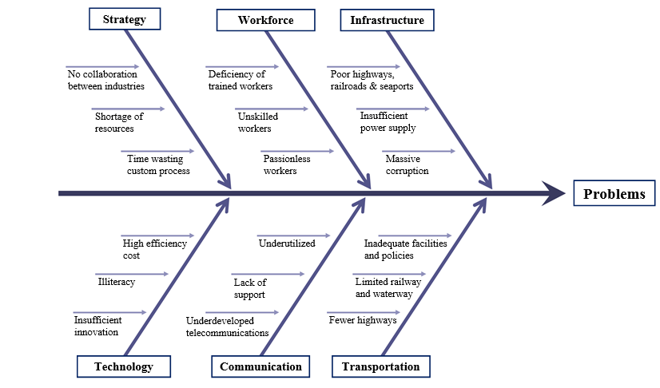

**Infrastructure:** Though Bangladesh is improving infrastructures day by day, it has many problems that should improve. We must elevate more highways, increase railroads, advance seaports, and airports. Besides, we have to give attention to power generation plants. Corruption must eliminate in these sectors.

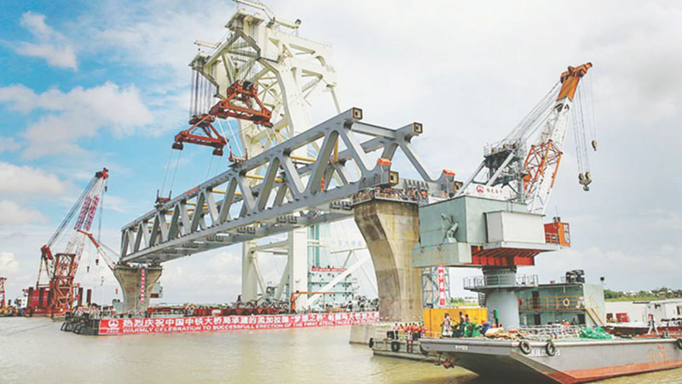

**Workforce:** We have a huge workforce in Bangladesh but filled with unskilled and untrained workers almost in every sector. We are undesired to test worker's capabilities. Lack of trained workers is one of the major problems that must eliminate for a better outcome.

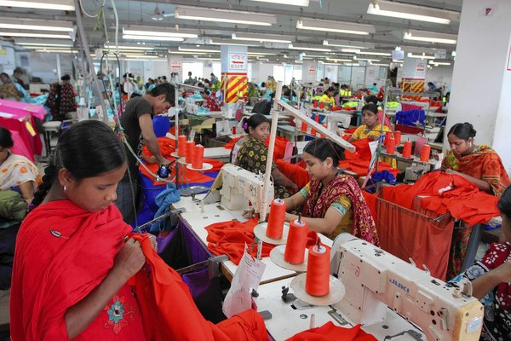

**Transportation:** Transportation is an integral part of supply chain logistics. We have to increase railways and waterways to reduce highway dependency. We must implicate proper policies and facilities to eschew transportation problems.

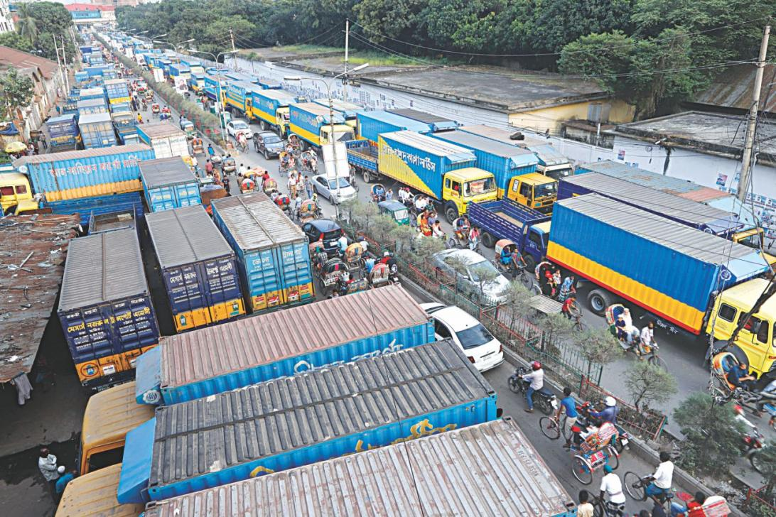

**Communication:** We have to make a Competitive situation allowing more companies in this sector. By doing this public can use the internet and other facilities at a cheaper rate. Miscommunication must eliminate.

**Technology:** The use of information and technology is increasing every day but we are still very much behind the world. We must focus on this sector by reducing efficiency cost, illiteracy, etc. ‘GOB’ has to influence the new generation towards more innovations.

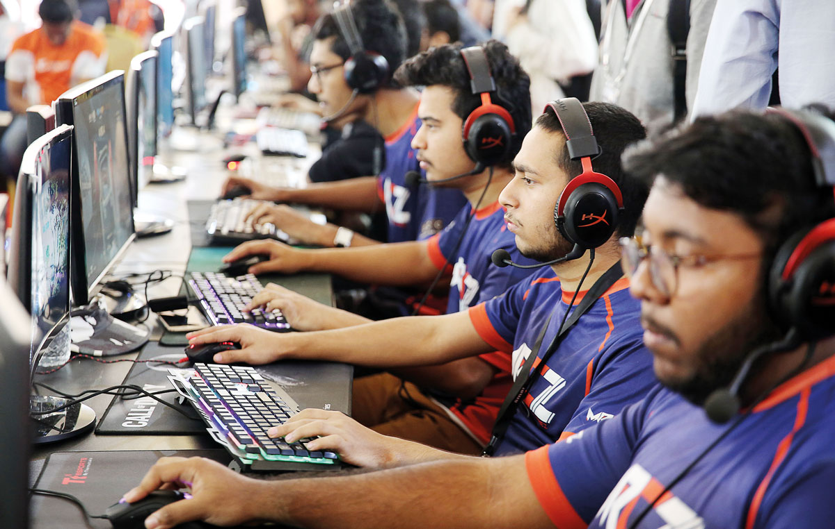

**Strategy:** ‘Bangladesh’ has a big problem with resources. We must encourage local or foreign investors to build a small part making factories for different products. That will make us independent from any other country and thus we can supply resources without delay. Large industries have to collaborate with small industries. Customs should be more flexible which will reduce the waste of time.

**Our Proposals**

1. We have to establish excellent infrastructure regarding power generation, highways, railroads, seaports, airports, and physical structure.
2. The communication system must improve. We need to focus on transport communication as well as telecommunication.
3. Easy transportation should be implemented so that no waste of time occurs on delivery.
4. Tax should mitigate for foreign investors shifting from ‘China’.
5. Political riots must be ended through peace.
6. The land price must be affordable so that investors can easily buy lands for building factories.
7. Separate economic zones should create for investors from different countries.
8. More power plants need to be set up so that the power supply would not disrupt.
9. Good training centers need to approve to build trained and skilled workforce.
10. The safety of workers must ensure by eliminating fire hazards and building collapses.
11. Maximum times we have to depend on other countries for procurement of raw materials like machinery, small parts of automobiles and electronics, raw materials for apparel and RMG (cotton, wool, fibers, silk, crude oil, etc.), chemicals, cement, rods, etc. It is necessary to reduce the import from other countries as much as possible and make arrangements for the production of raw materials in this country.
12. The path of vertical collaboration between the factories should be paved.
13. We need to build a huge local market.
14. Corruption in international ports have to reduce and the whole arrangements have to make faster and easier.
15. Corruption in the whole country must stop through proper law enforcement.
16. More plants need to be planted to produce raw materials for the pharmaceuticals and apparel industries.
17. Environmental pollutions, as well as factory wastages, must be reduced by implicating some new rules to make ‘Bangladesh’ a carbon-negative country as much as possible.

**Proposed Solutions & Policy Implications**

1. We can make our infrastructure better by giving importance. We can already see a great advancement in infrastructural development for roads and highways. However, the timely implementation of ongoing projects is a big challenge. Therefore, we have to finish all the ongoing projects as soon as possible. Most of our flyovers and bridges do not meet the criteria of standards. A good consultancy force has to arrange to reduce this problem.
2. We have to ensure a modern transportation system, which will more chapter, secured, comfortable, and speedy. Encouraging non-government transportation and communication systems can solve transportation and communication problems (playing a vital role in controlling transport quality and fare, quality of telecommunication and internet) and developing skilled workers in these sectors through proper training. Electric vehicles can be used to reduce the consumption of fuel so that the environment can remain safe.
3. We can offer tax holidays for 15 years’ period or more. Tax exemption or Tax reduction can be the following:

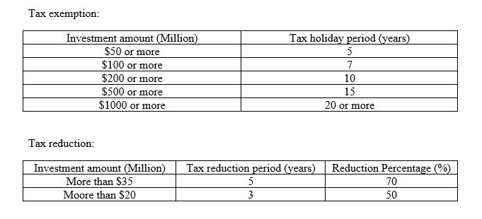

1. We have to make different economic zones, industrial parks, and EPZs for different countries with proper benefits and lower the land cost for foreign investors or foreign-local join investors with an ‘EMI’ system for 15 to 20 years. Already many economic zones are under construction. We must make them ready as soon as possible. Some potential areas to make economic zones are:

* Maheskhali
* Bagerhat
* Mirsarai
* Kustia
* Jamalpur
* Habigonj
* Nilphamari
* Natore
* Sirajganj
* Narshingdi
* Shariatpur
* Maulavibazar
* Manikganj
* Dohar, Dhaka
* Cox's Bazar
* Bhola

1. We are undesired to test worker’s capabilities. To make workers more efficient, skilled, and trained it is necessary to build some good training centers. Training centers must be free of cost for all kinds of workers and the government of Bangladesh must maintain these training centers.
2. All factories or buildings must have safety instruments and safety measures to deal with any kind of disasters or hazards under the supervision of the government of Bangladesh.
3. We will eliminate all kinds of corruption in roads and factories by implication of proper rules and regulations. Besides, modern business law has to implicate to make sure the safety of foreign investors.
4. Customs service in international ports (road/Sea/air) has to be flexible and free trade years have to announce for export-oriented industries.
5. Small [organizations](https://www.google.com/search?sxsrf=ALeKk02B2Ol8NsGeTTRhEEBl-HZmD53q-g:1593121124085&q=organizations&spell=1&sa=X&ved=2ahUKEwj1nb3V9p3qAhWJ73MBHU_CAj4QkeECKAB6BAgVECU) (small parts making industries for automobiles and electronics, raw materials for apparel industries and RMG, distribution companies, chemical industries) have to get the most priorities.
6. We have to fully activate industry 4.0 to the whole manufacturing sector as soon as possible.
7. By 2030-power generation will have to be 50% higher than at present. Power generation can be increased from renewable sources like wind, waste, and solar energy.
8. Wastages can be eliminated by implicating efficient inventory management, by establishing preventive maintenance and by adopting a closed-loop manufacturing system. Also, proper reuse, recovery, or sorting of waste materials can reduce a big amount of wastage from the whole manufacturing sector.
9. Farmers need to be encouraged more with improved facilities for planting medicinal plants, cotton cultivation, and chemical pesticides.

**Feasibility Test (SWOT & PESTEL Analysis of our Proposal)**

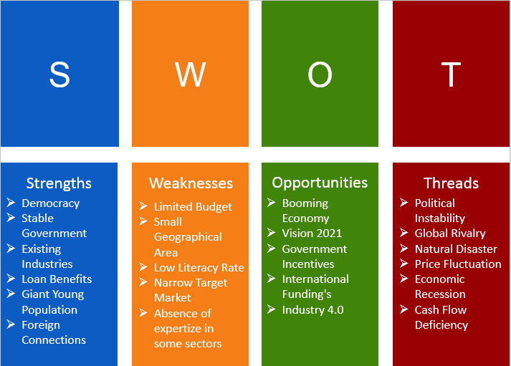

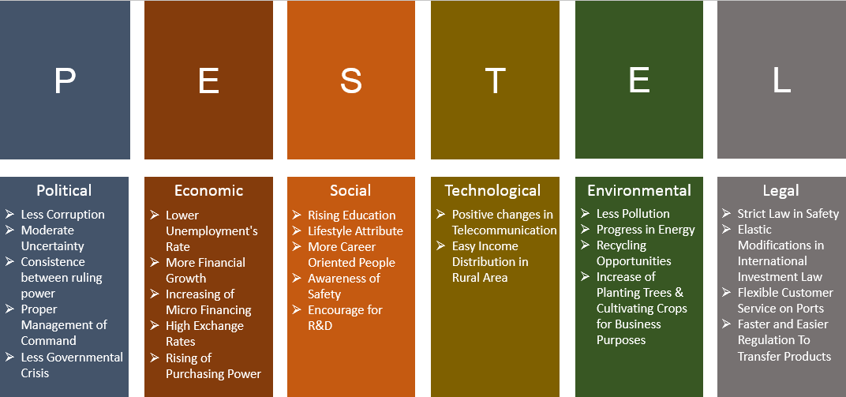

**Conclusion**

Bangladesh is moving forward every day; the confidence of foreign investors in Bangladesh is also increasing. The Country can move forward by overcoming some major problems. But these problems can be solved by following our proposed plans along with reducing doubtfulness, greater volatility, unprecedented and unexpected risks resulting in an efficient supply chain network throughout the country.